WHY SKETCHING IS AN IMPORTANT PART OF THE DESIGN PROCESS
In the early stages of my web design career, I would start designing directly in Photoshop without any planning. This method often led me to designing websites with terrible user experiences! Sketching helps discover potential issues and solutions early, prior to starting the design and development stages.

FIRST STEP: RESEARCH
Before sketching, you need to have a clear understanding of the problem you are solving or the business objective for something new you are designing. Research is where the initial ideas begin to build, so that you can envision what you are designing. Sketching helps you extract numerous ideas out quickly before you enter into a graphics editor to start designing the look and feel.
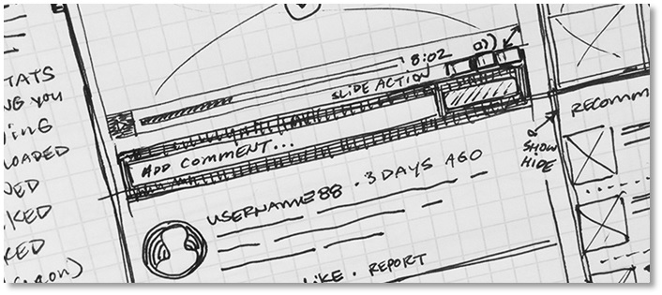

NEXT STEP: SKETCH
Sketching ideas are the first steps in the design process and something every designer should do. Sketching is not just limited to designers, it occurs in many careers that require something to get built. The beauty of sketching is that you are not required to be an artist to produce them. Sketching is only to help explore and explain design concepts.
Sketches can be easily created using pen and paper or a whiteboard. Using something permanent like a pen or marker is best. The idea is to keep your sketches fast, rough and dirty. This helps you worry less on design aesthetics and focus more on rapid formulation of ideas.
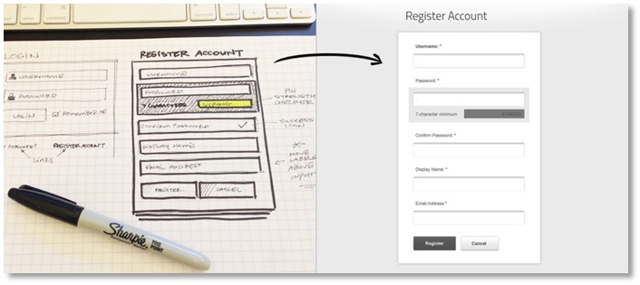

WIREFRAMES
There is a common misconception that sketches and wireframes are the same; however, they are not. Wireframes are more of a refinement of the ideas formed during the sketching process and dictates the finer details of a user interface. Sketching should always come before the wireframe stage.

WORKING AS A GROUP
If working in a group, sketches from team members are reviewed together in order to compare and consolidate the best ideas. Group feedback can be verbal (or written on post-it notes) and appended to the sketches. The best ideas from each group member’s sketches are reviewed and often a super vote will take place.
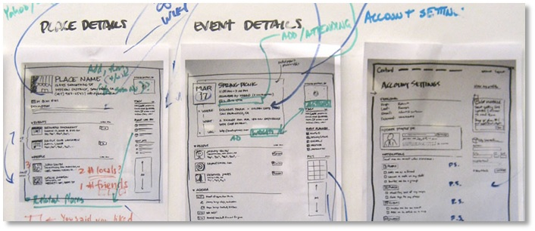
The super vote process helps determine the best ideas from each sketch. At this point, another round of sketching can take place or you can move directly into the wireframing process. Wireframing is a low fidelity design (usually in black and white) that shows all of the ideas from the sketch phase laid out in a structured fashion.
Creating wireframes can be done with ease. There are many wireframing software options available online; there's also a graphics editor, such as Adobe Illustrator. Based on the best selected features from each sketch, you use the wireframe process to provide structure to the layout of your design.

SKETCHING BENEFITS
- Saves time in the workflow process.
- Great for brainstorming ideas and collaborating with team members.
- Refines the wireframing process
- Helps evaluate the feasibility of features and eliminate layout and functionality issues.
- Anyone can sketch ideas.
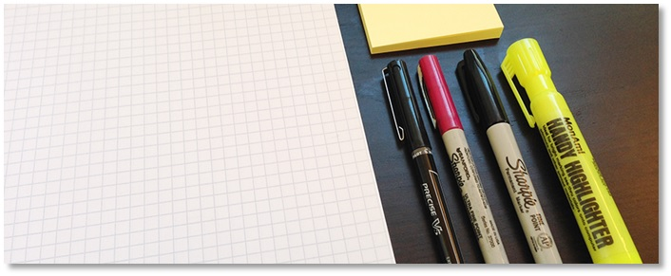

SKETCHING TOOLS
- Pen
- Paper
- Sharpie marker
- Highlighter
- Post-it notes
- Graph paper
- Whiteboard
- What are the requirements for iOS 9?
- Installation. iOS 9 is a smaller update than iOS 8, requiring just 1.3 GB of space, compared to 4.58 GB for iOS 8. Additionally, iOS 9 includes an option to temporarily delete apps to allow the update to install. Once the update has been installed, the apps will be automatically reinstalled from the App Store.
- iOS 9 incorporated many feature updates to built-in apps. Most notably, Notes received the ability to draw sketches with different tools, image insertion, prominent visual appearance for website links and map locations, and advanced list formatting; an all-new Apple News app aggregates articles from different sources; and Apple Maps received mass transit support, although in a limited number of locations at launch. Major new system updates include proactivity, where Siri and advanced search are combined to make the operating system more contextually aware of information (such as time and location), and can provide the user with information ahead of time. For searching, the proactive intelligence can display instant results in a widget-like format, including weather, sports, news, and more. iOS 9 also added multiple forms of multitasking to the iPad. In iOS 9.3, Apple added a Night Shift mode that changes the color of the device's display to a warmer, less "blue light" containing shade, to reduce any negative eye health effects on users' circadian rhythms. Additionally, iOS 9 brought new user experience functions, including Quick Actions, and Peek and Pop, based on the touch-sensitive display technology in the iPhone 6S. Quick Actions are shortcuts on home screen app icons. Users can preview ("Peek") at content without moving away from the current screen before they enter ("Pop") the previewed content into full view.
- Reception of iOS 9 was positive. Critics praised proactivity and Siri for making the Notification Center a central location for all information, and the potential for future updates to improve the functionality. The new multitasking features for the iPad were complimented, as were drawing and photo insertion in the Notes app. However, Apple News was criticized for a low number of decent-looking articles, and Apple Maps was criticized for the limited geographical availability of mass transit support.
- Five days after release, Apple announced that iOS 9 had been installed on more than 50% of "active" iOS devices, which Apple described as the "fastest adoption rate ever for a new operating system".
- iOS 9 is the last version of iOS to feature the classic slide to unlock. With the release of iOS 10, Apple introduced the Today view, which was accessed on the lock screen by swiping to the right. Apple removed slide to unlock in iOS 10 because it would create confusion when users were trying to unlock their phone by sliding the screen, but instead of unlocking the phone, it took them to the new Today view.^{[3]} iOS 9 is the last version of iOS compatible with devices with the 30 pin dock connector, such as iPhone 4s, iPad 2, and iPad 3rd Generation.

What is a design concept?
An effective design concept makes the goal of the product explicit and serves as the foundation upon which the product is built.
Developing a design concept demands a clear understanding of the type of problems to be solved, the ideal aesthetic style, the target audience, and the client’s needs (if working on an external project).
Investing time into creating a solid design concept reduces the risk of running into dead ends once work is underway, and of investing money into a project without a clear purpose.

What are the different stages in creating a design concept?
When preparing to write a design concept, the first step is always defining the problem to be solved — which may be a solo or group task.
For the latter, consider an ideation session that brings key members of the design (and other teams) together to make the problem and solution as concrete as possible.
Those with user or client experience in a marketing or support context may have valuable input, for example.
When it’s clear what and who a product is for, the agreed design concept should be drawn up, consisting of both visuals and text (with a design concept statement).
This can be brief, but it must be simple: anyone should be able to understand the concept behind the design.
The visual elements of a design concept may comprise sketches (covering user flow, layout, menus, etc.) and basic renderings, which help demonstrate how users will interact with the product.
Multiple design options can be explored, as designers work to determine the most effective, user-friendly structure and aesthetics.
User and competitor research should also be prioritized, to identify exciting opportunities.
The elements that can be placed on the canvas in most design applications
When designing user interfaces, we often receive requests for components or designs that go beyond what we can achieve with plain components. This is where Canvas comes in to help us.
With Canvas, we have the ability to decide what to draw on a screen, even behind components that have already been drawn. This powerful tool allows us to create more complex and dynamic interfaces.

What is a vector file?
Vector files use mathematical equations, lines, and curves with fixed points on a grid to produce an image. There are no pixels in a vector file. A vector file’s mathematical formulas capture shape, border, and fill color to build an image. Because the mathematical formula recalibrates to any size, you can scale a vector image up or down without impacting its quality.
Learn more about vector file types

What is the difference between raster and vector files?
Raster and vector files are the two most popular formats used for visual content. They represent images in very different ways, so there’s a lot to consider when deciding which one to use. Some of the main differences between raster and vector include:

Resolution.
One of the main differences between raster and vector files is their resolution. The resolution of a raster file is referred to in DPI (dots per inch) or PPI (pixels per inch). If you zoom in or expand the size of a raster image, you start to see the individual pixels.
Raster files display a wider array of colors, permit greater color editing, and show finer light and shading than vectors — but they lose image quality when resized. An easy way to tell if an image is raster or vector is to increase its size. If the image becomes blurred or pixelated, it’s most likely a raster file.
With vector image files, resolution is not an issue. You can resize, rescale, and reshape vectors infinitely without losing any image quality. Vector files are popular for images that need to appear in a wide variety of sizes, like a logo that needs to fit on both a business card and a billboard.

Uses.
Digital photographs are usually raster files. Many digital cameras automatically shoot and save photos as raster files — and the images you see online are often rasters, too. Raster files are also commonly used for editing images, photos, and graphics.
Vector files work better for digital illustrations, complex graphics, and logos. That’s because the resolution of vectors remains the same when resized, making them suitable for a wide variety of printed formats.
Some projects combine both raster and vector images. For example, a brochure may use vector graphics for the company logo but raster files for photography.

File sizes.
Raster files are generally larger than vector files. They can contain millions of pixels and incredibly high levels of detail. Their large size can impact device storage space and slow down page loading speeds on the web. However, you can compress raster files for storage and web optimization to make sharing faster and easier.
Vector files are much more lightweight than raster files, containing only the mathematical formulas that determine the design.

Compatibility and conversion.
You can open raster files in many different apps and web browsers, making them easy to view, edit, and share. Vector files aren’t as accessible — many vector file types require specialized software to open and edit the files. Though it can present some challenges, it’s possible to convert vector files to raster or raster files to vector when needed.

File and extension types.
Your software will usually determine your file type, whether it’s raster or vector. There are multiple types and extensions of both raster and vector files, each with its own features. Learn more about some of the common ones:

RASTER FILE TYPES.

File type

Extension
Joint Photographic Experts Group (JPEG)
.jpg
Portable Network Graphics (PNG)
.png
Graphics Interchange Format (GIF)
.gif
Bitmap Image File (BMP)
.bmp
Tagged Image File Format (TIFF)
.tiff
Adobe Photoshop File (PSD)
.psd
You can open and edit raster files in Adobe Photoshop.

VECTOR FILE TYPES.

File type

Extension
Scalable Vector Graphics (SVG)
.svg
Encapsulated PostScript File (EPS)
.eps
Adobe Illustrator File (AI)
.ai
Collaborative Design Activity (COLLADA)
.dae
PostScript (PS)
.ps
Enhanced MetaFile (EMF)
.emf
Create a new artboard and set specific dimensions:
Select the Artboard Tool (Shift + O). Click on the artboard that you wish to size. In the Control Bar at the top of your Illustrator window, you will find the size of your artboard. Enter desired width and height in the Width and Height boxes.

WHAT ARE ARTBOARDS?
An artboard is a virtual canvas. What's great about Photoshop and Illustrator is that you can have multiple canvas in a single document. Hooray!
This is extremely useful if you need to create multiple frames for your animation project. Being able to see all of the artboards next to one another helps keep the continuity of your design consistent throughout your entire project. And, you're able to make small tweaks without having to open multiple projects.

HOW TO CREATE ARTBOARDS
It's one thing to know that artboards exist, but how do you get started with these handy tools? Here's how you can create artboards in Photoshop and Illustrator.

HOW TO CREATE ARTBOARDS IN ILLUSTRATOR
When you launch Illustrator you're met with a pop up screen full of options. Even though this can be overwhelming there are just a few things you need to set in order to get started.
Here's how to create multiple artboards in Illustrator:
- Click Create New... at the top left
- Find the Preset Details panel to the right
- Enter your desired frame width and height
- Enter in how many artboards you would like to start with
- Click Advanced Settings
- Set Color Mode to RGB Color
- Set Raster Effects to Screen (72 ppi)
- Finish by clicking the Create button at the bottom right.

HOW TO CREATE ARTBOARDS IN PHOTOSHOP
This process is very similar to creating artboards in Illustrator but with one key difference.
Here's how to create an artboard project in Photoshop:
- Click Create New... at the top left
- Find the Preset Details panel to the right
- Enter your desired frame width and height
- Click the artboards checkbox
- Set Resolution to 72
- Set Color Mode to RGB Color

Moving and Creating Artboards
The workflow for creating new artboards in Photoshop and Illustrator are different, but the process very easy. Here's a quick guide for creating and managing artboards once you're in Photoshop and Illustrator.

MANAGING ARTBOARDS IN ILLUSTRATOR
While you're in the project you can re-arrange your artboards and even create new artboards. You're not limited to the number of artboards created at the beginning of the project.
When you're ready to start editing your artboard layout equip the artboard tool from the tools palette. You can find the tool palette on the left side of Illustrator when using the default layout. See the image below for what this tool currently looks like. Also, the keyboard shortcut for Illustrators artboard tool is Shift+O, which is a very quick way to keep your workflow lightening fast!
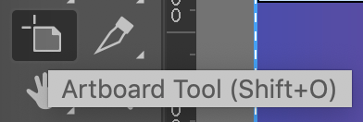
The artboard tool in Illustrator

